a & b : Add CalculatorPlus.py and First run of CalculatorPlus.py
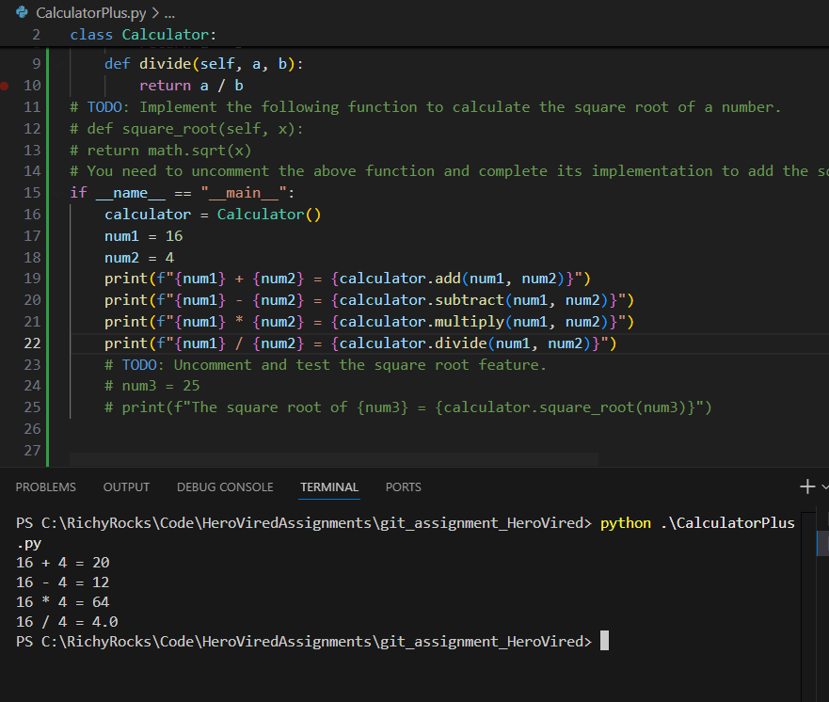

c. Merge dev branch to main branch and create a release version 1 for Calculator Plus app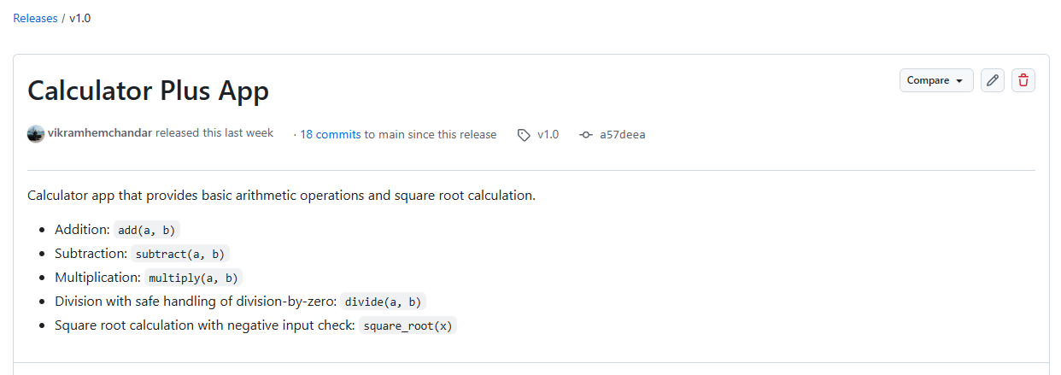
d. Added one of the classmate as colloborator

e & f. Created a new feature/sqrt and add the square root function
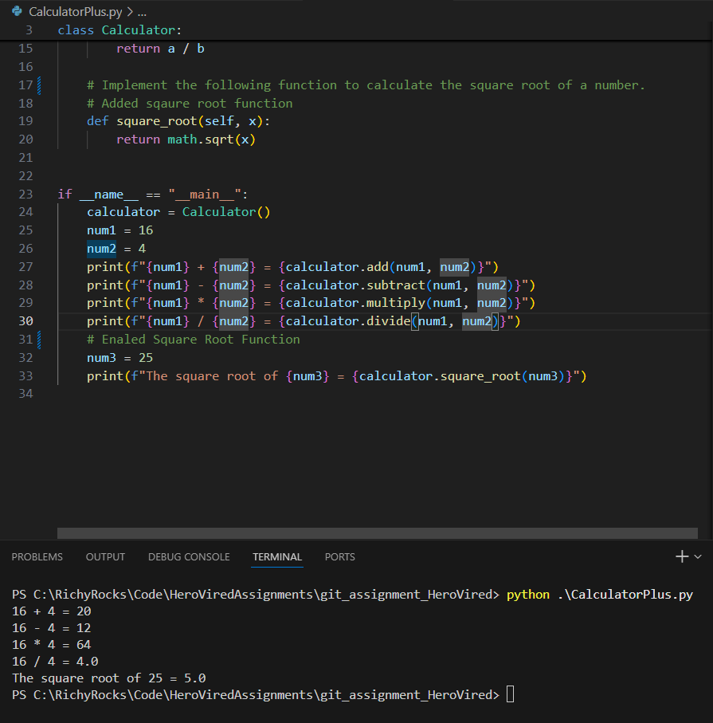

g. Switched back to dev branch and fixed the bug that number cannot divide by ZERO
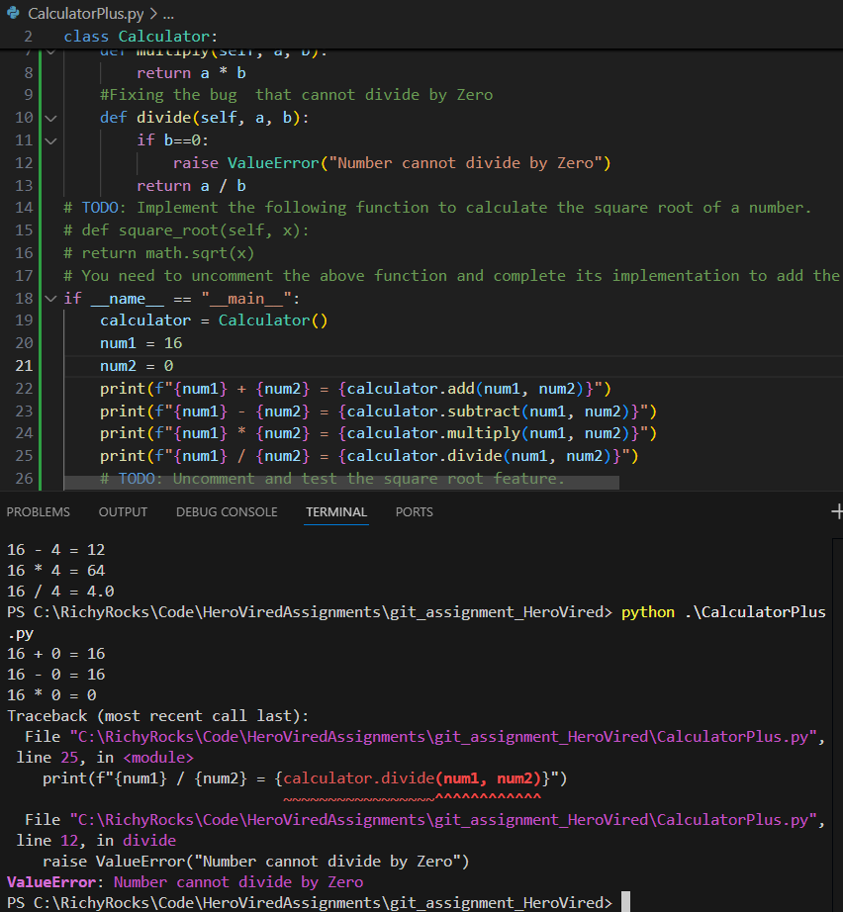

h & i. Raise Pull Request to merge the code from Dev branch to main branch and request a code review
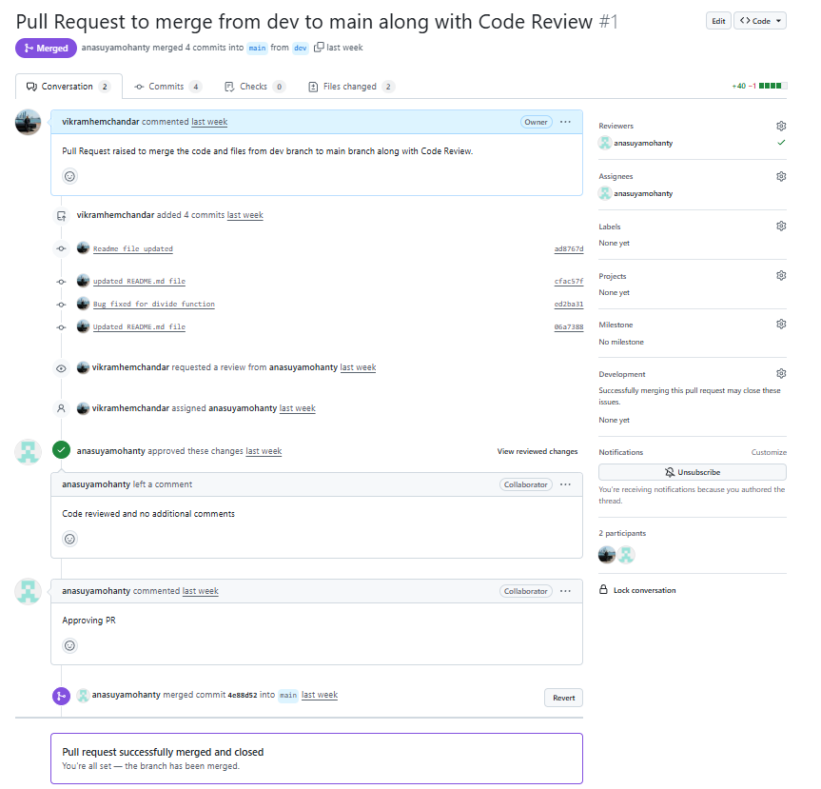

j. Merged the feature/sqrt to dev branch and switched back to dev branch
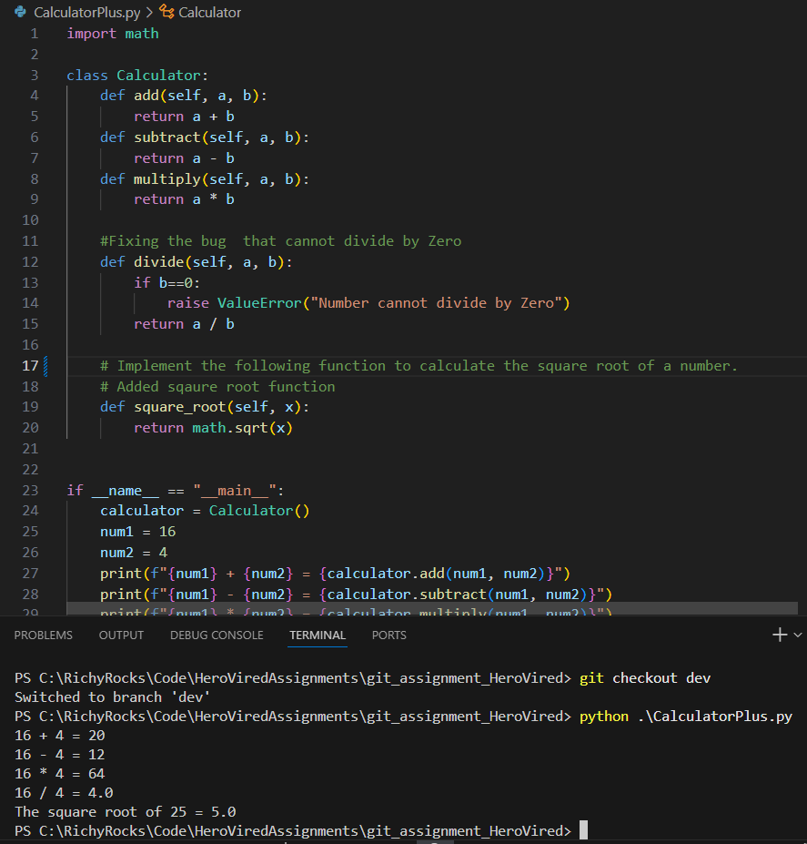

j. Scenario -2 : Testing a number divide by zero in dev branch
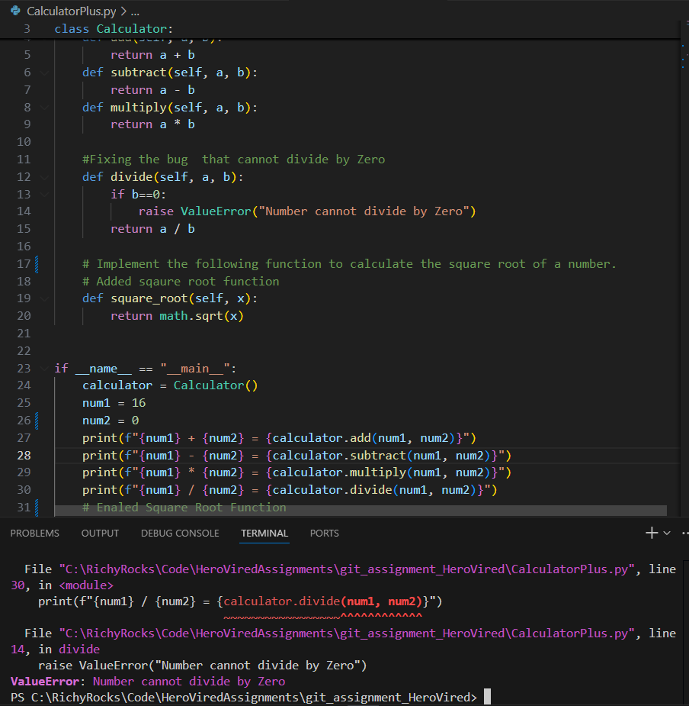

k. merged the dev branch to main branch and created a release with version 2
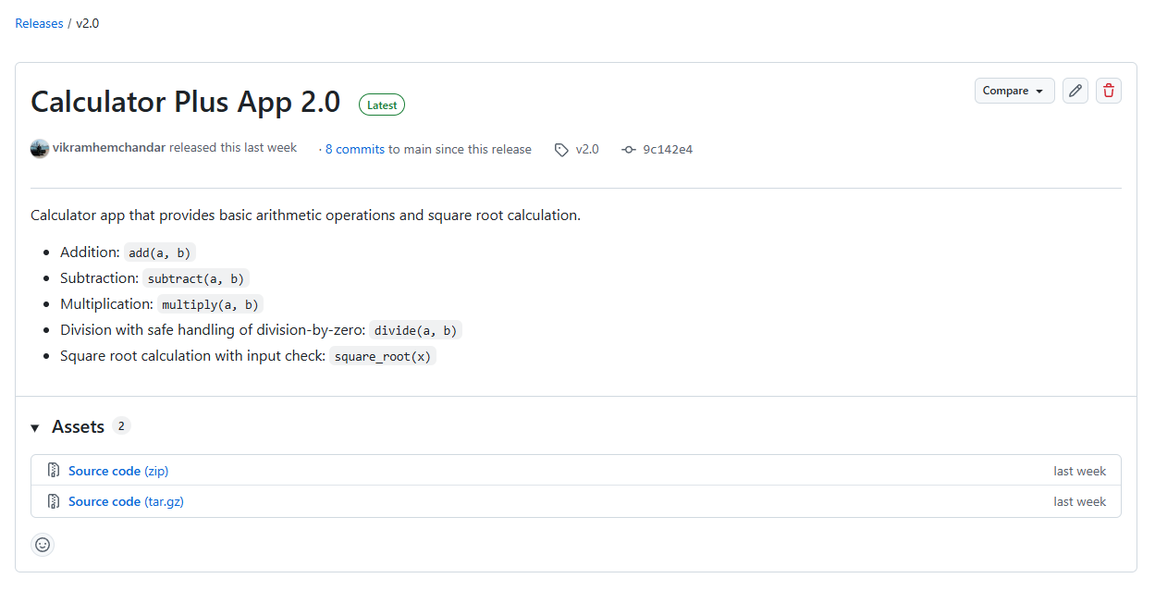

GeometryCalculator.py
a. Create a new branch feature/circle-area
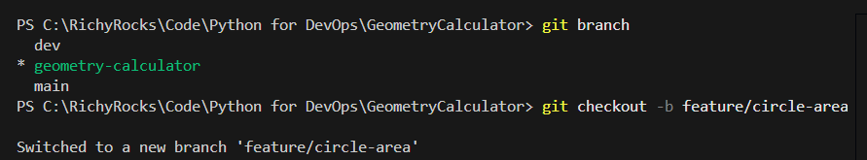

b. Stash changes for circle area
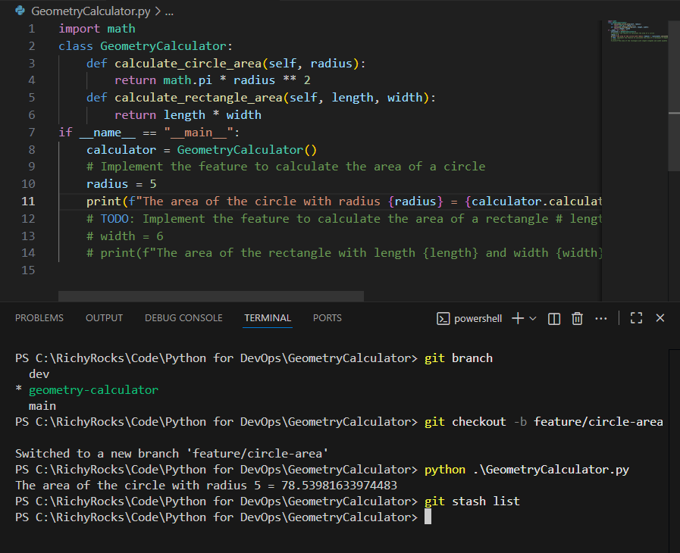

After stash
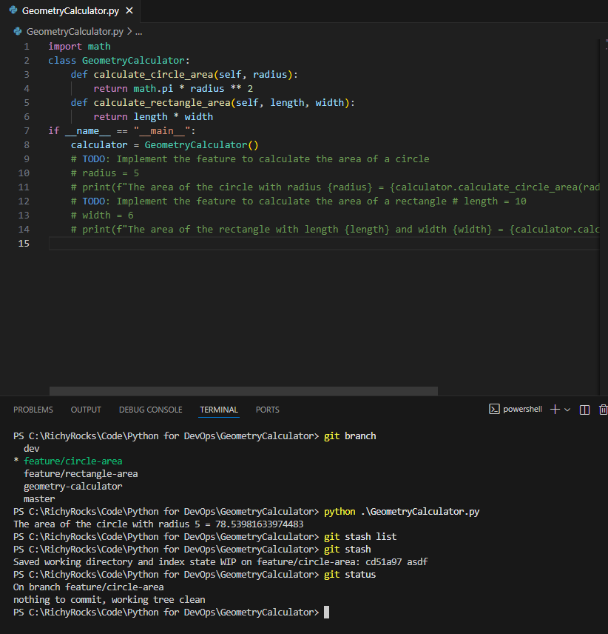

c. Create a new branch feature/rectangle-area
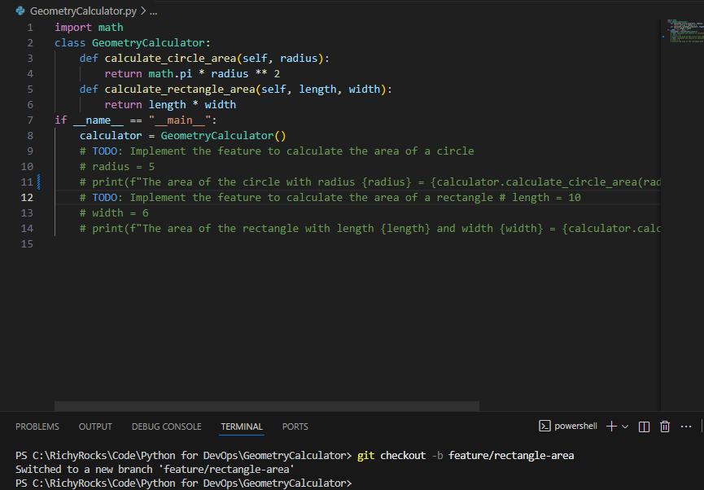
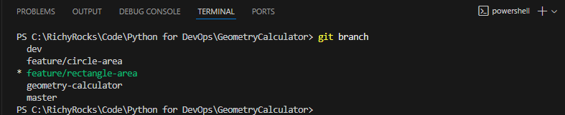

d. Stash changes in Rectangle feature
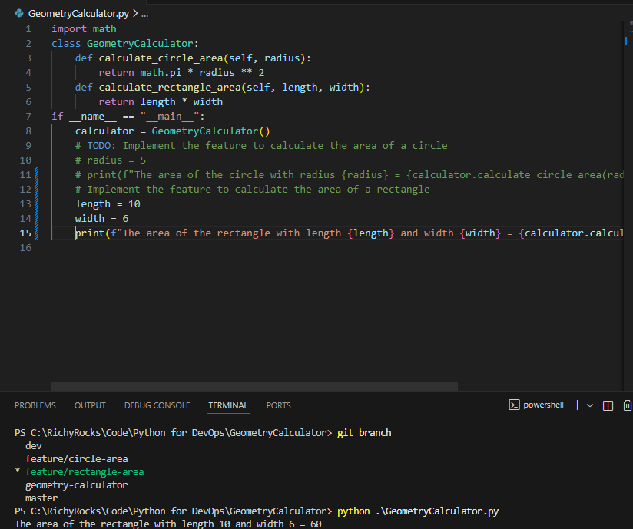

After stash in feature/rectangle-area branch
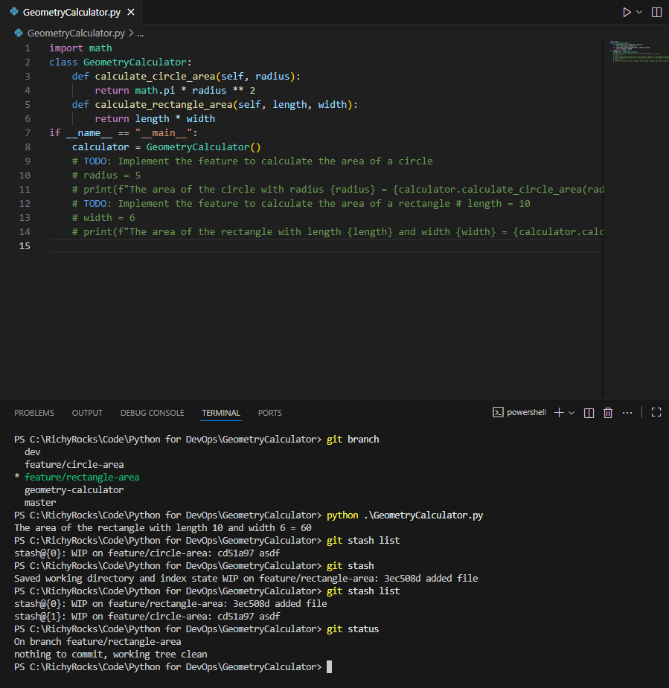

e. Switch back to feature/circle-area
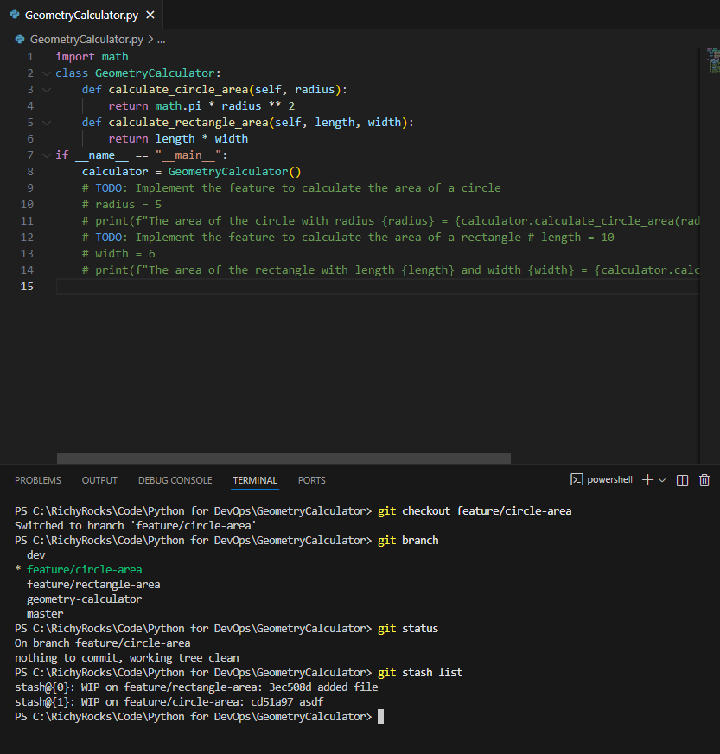

After stash apply on feature/circle-area
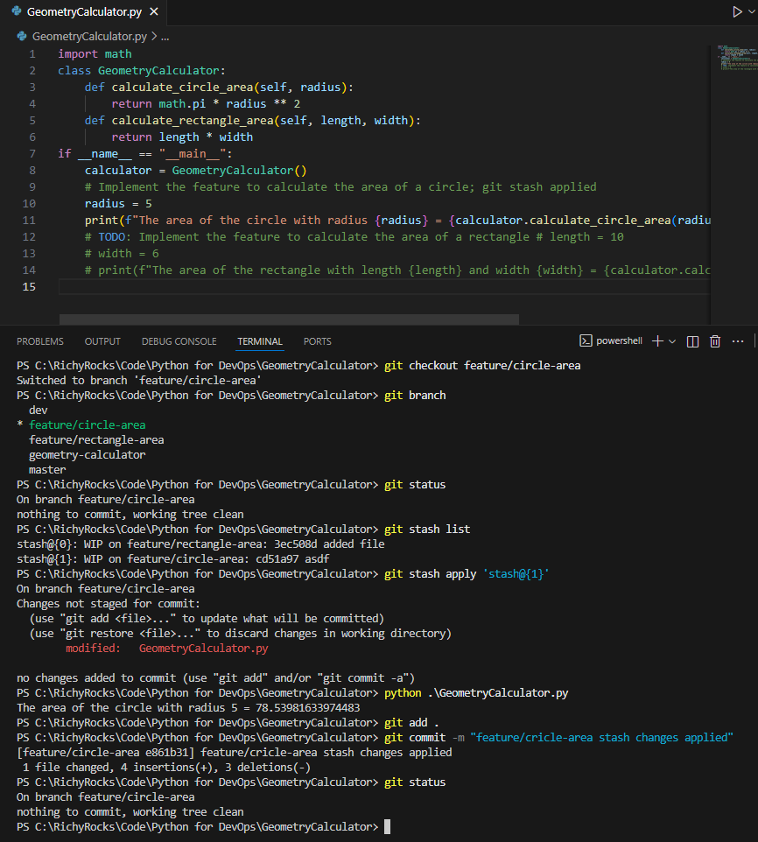

f. Commit and push feature/circle-area branch

g. Switch back to feature/rectangle-area
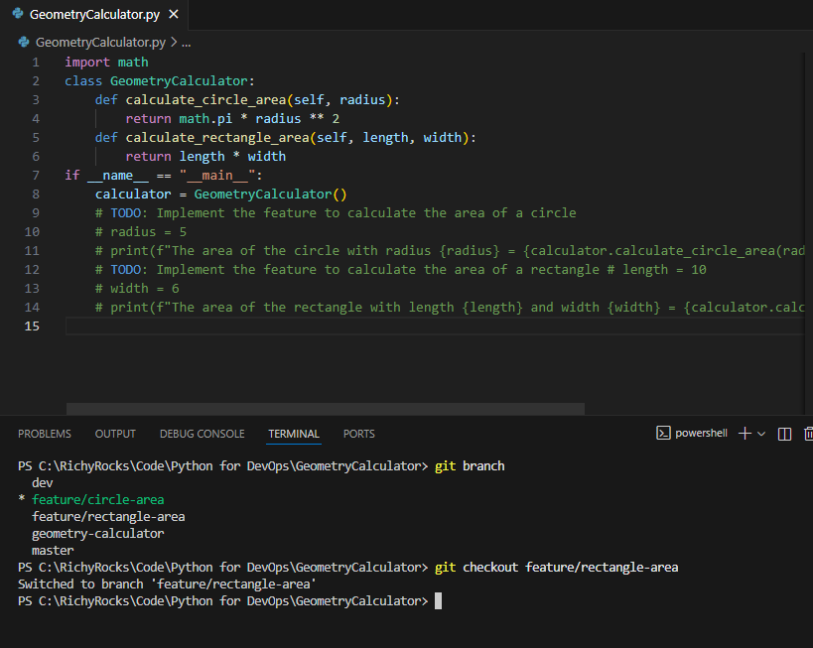

h. After stash changes applied on feature/rectangle-area
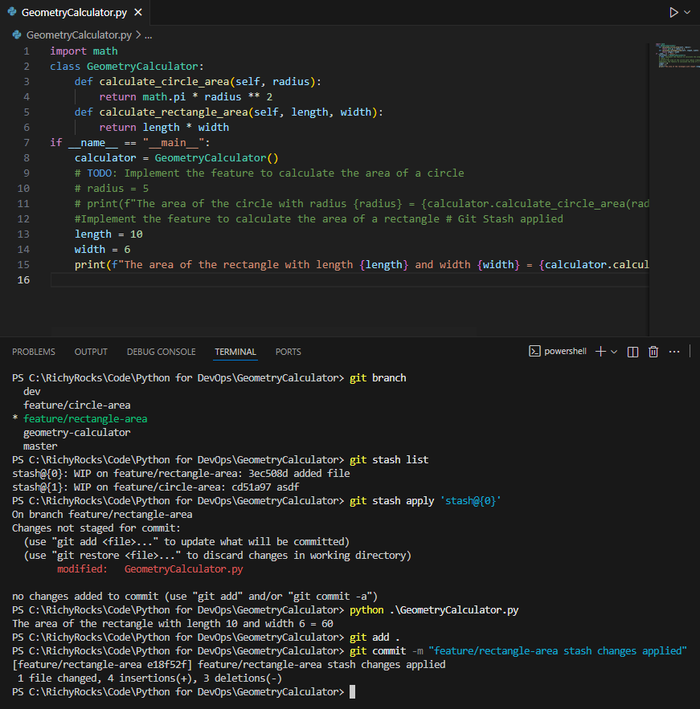

i. Create two Pull Requests to merge both feature/circle-area and feature/rectangle-area branches to dev branch
Pull Request to merge the code feature/circle-area branch to dev branch
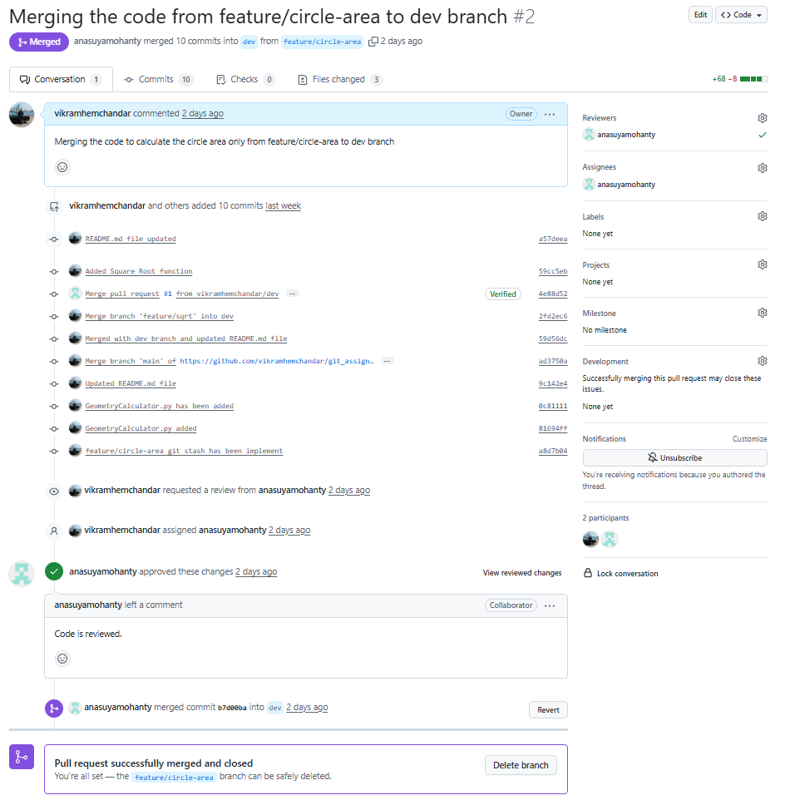

Pull Request to merge the code feature/rectangle-area branch to dev branch
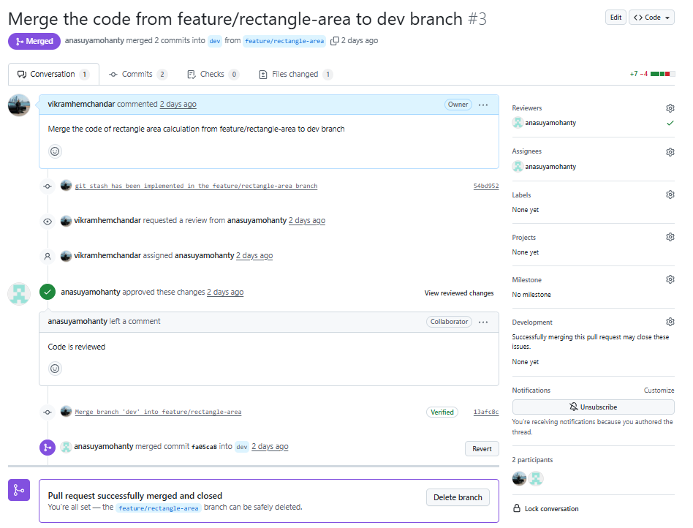

j. Raise Pull Request to main branch ad review the code
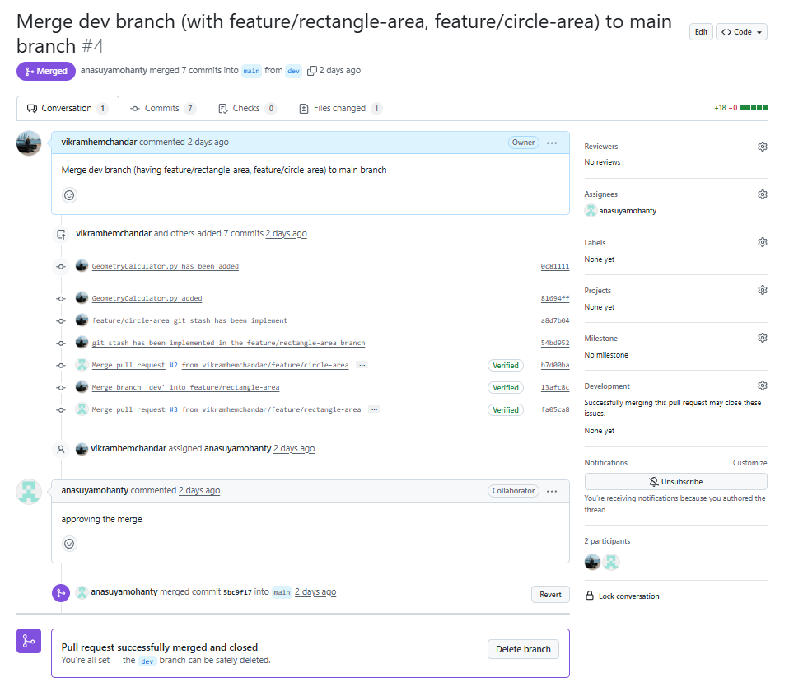

LFS
Track the binary file
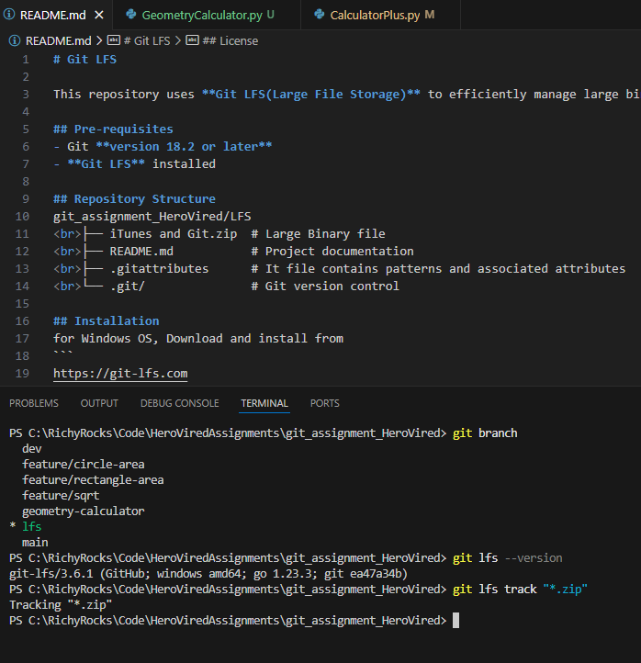

Adding the binary files to the repo
